

**MODERN ACADEMY**

**FOR ENGINEERING & TECHNOLOGY**

**Computer Engineering and Information Technology Department**

**Academic Year 2022/2023**



**Online HomeMade Food System**

**وجبة**

**Team**

|  |  |
| --- | --- |
| **Name** | **ID** |
| **Mohamed Refaat Mohamed Abo-Ali** | **16769** |
| **Ahmed Mohsin Ahmed Abdel-Ghani** | **4190392** |
| **Ahmed Mohamed Ahmed Naguib** | **4190581** |
| **Yousef Hesham Yousef Kamal** | **4190556** |
| **Assem Yousry Abdel-Azeem Nasr** | **4190523** |
| **Esraa Sherif Hussein Abdel-Kawy** | **4190031** |
| **Alaa Mohamed Abdel-Reheem Sayed** | **4191029** |

**Aknowledgement**

We take this occasion to thank God, almighty for blessing us with his grace and

taking our endeavor to a successful culmination.

We extend our sincere and heartfelt thanks to our esteemed guid,

**Dr\Sabry Mohammed Abdel-Moaty and Dr\Seham Muawad Ali**

for their constant supervision and guidance on my project. I also want to thank them for the information they provided us with the right guidance and advice at crucial junctures and for showing us the right way. We extend our sincere thanks to our respected head of the division **Dr.Khalid Ahmed Morsy**,

for allowing us to use the facilities available. We would like to thank the other faculty members also, on this occasion.

Special Thanks to **Dr.Said Darwish** who left our world for his endeavor to make the Academy the highest centers.

Special Thanks to the General Authority for Hygiene in Cairo and the Director of the Engineering Planning Department Eng.Mahmoud Mansour.

Last but not least, we would like to thank friends for the support and encouragement they have given us during our work.

Lastly, we wish to show our gratitude and love to our parents for their love and support. They supported our financially and encouraged us to work hard on this project.

Contents

**Chapter ( 1 )** 2

**Introduction to Database Fundamentals** 2

**Properties of a Database 2**

**The Database Management System 3**

**Layers of Data Abstraction 4**

**Prevalent Database Models 6**

**The Hierachical Model** 6

**The Hierachical Model Fig** 6

**The Relational Model** 7

**Advantages of using the relational model** 7

**Chapter ( 2 )** 12

**Introduction to Web Design** 12

**Overview about data analytics** 12

**Design Process** 14

**Chapter ( 3 )** 15

**Function Requirements** 15

**Non-Functional Requirements** 16

**Problem & Solution** 18

**System Functions** 19

**Survey** 20

**ERD** . 25

**Schema** 26

**Use Case Description** 27

**Use Case Diagram** 45

**Bussiness Model** 46

**UI Design** 48

**Chapter ( 1 )**

**Introduction to Database Fundamentals and Data Analysis Approach**

### Properties of a Database

A database is a collection of interrelated data items that are managed as a single unit

This definition is deliberately broad because so much variety exists across the various software vendors that provide database systems. For example, Microsoft Access places the entire database in a single data file, so an Access database can be defined as the file that contains the data items.

Oracle Corporation defines its database as a collection of files that are managed by an instance of its database software product. An instance is a copy of the database software running in memory

Microsoft SQL Server and Sybase Adaptive Server Enterprise (ASE) define a database as a collection of data items that have a common owner, and multiple databases are typically managed by a single instance of the database management software.

This can all be quite confusing if you work with multiple products, because, for example, a database as defined by Microsoft SQL Server or Sybase ASE is exactly what Oracle Corporation calls a schema.

A database object is a named data structure that is stored in a database. The specific types of database objects supported in a database vary from vendor to vendor and from one database model to another.

Database model refers to the way in which a database organizes its data to pattern the real world.

Data analysis is the process of examining and interpreting data to extract insights and gain knowledge about a particular subject or phenomenon. It involves using analytical and statistical tools to explore, organize, and summarize data to draw meaningful conclusions. In this article, we will discuss the different approaches to data analysis and their importance in making informed decisions.

# Approaches to Data Analysis

There are several approaches to data analysis, including exploratory data analysis (EDA), confirmatory data analysis (CDA), and predictive data analysis (PDA).

# Exploratory Data Analysis (EDA):

EDA is an approach to data analysis that involves exploring and visualizing the data to identify patterns, trends, and relationships. EDA is useful for gaining a better understanding of the data and generating hypotheses for further testing. EDA techniques include data visualization, summary statistics, and clustering

# Confirmatory Data Analysis (CDA):

CDA is an approach to data analysis that involves testing pre-specified hypotheses using statistical methods. CDA is useful for confirming or rejecting hypotheses and making

inferences about the population based on a sample. CDA techniques include hypothesis testing, statistical inference, and regression analysis .

# Predictive Data Analysis (PDA):

PDA is an approach to data analysis that involves using statistical and machine learning models to make predictions about future outcomes based on historical data. PDA is useful for forecasting future trends and identifying patterns and relationships that can guide decision-making. PDA techniques include time series analysis, decision trees, and neural networks .

# Importance of Data Analysis Approach:-

Data analysis approaches are essential because they provide a structured and systematic way of examining data to extract insights and make informed decisions. By using the appropriate data analysis approach, individuals and organizations can gain a better understanding of the data, identify patterns and trends, test hypotheses, make predictions, and develop effective strategies.

For example, an e-commerce company can use EDA to explore customer data and identify trends in buying behavior, such as the most popular products, the most common purchase times, and the most common payment methods. Based on the insights gained from EDA, the company can develop targeted marketing campaigns and

product offerings to increase sales and customer satisfaction.

Similarly, a healthcare organization can use CDA to test hypotheses about the effectiveness of a new drug or treatment using statistical methods. By analyzing the data and making inferences based on the results, the organization can make informed decisions about whether to adopt the new drug or treatment and how to allocate resources.

Finally, a financial institution can use PDA to predict future market trends and identify potential risks and opportunities. By using machine learning models and predictive analytics, the institution can forecast future market conditions and develop investment strategies that maximize returns and minimize risks .

Exploratory Data Analysis (EDA): EDA is a useful approach for getting a preliminary understanding of the data. It involves using data visualization techniques, such as scatter plots, histograms, and box plots, to explore the data and identify patterns and relationships. EDA can help researchers generate hypotheses for further testing and gain insights into the data that might not be apparent through other methods.

Confirmatory Data Analysis (CDA): CDA is a useful approach for testing pre-specified hypotheses using statistical methods. It involves using statistical inference techniques, such as hypothesis testing and confidence intervals, to draw conclusions about the population based on a sample. CDA can help researchers confirm or reject hypotheses and make inferences about the data with a high degree of confidence.

Predictive Data Analysis (PDA): PDA is a useful approach for making predictions about future outcomes based on historical data. It involves using machine learning algorithms and statistical models to identify patterns and relationships in the data and make predictions. PDA can help researchers forecast future trends and identify potential risks and opportunities.

Data Analysis Pipeline: A data analysis pipeline is a sequence of steps that researchers follow to analyze the data. The pipeline typically includes data cleaning, data preprocessing, exploratory data analysis, confirmatory data analysis, and predictive data analysis. By following a structured pipeline, researchers can ensure that their analysis is systematic and reproducible.

Data Visualization: Data visualization is a critical component of data analysis. It involves using graphical representations, such as charts, graphs, and maps, to communicate insights and patterns in the data. Data visualization is useful for making complex data more accessible and understandable to a wide audience.

In summary, data analysis approaches are essential for gaining insights and making informed decisions based on data. EDA is useful for exploring data and generating hypotheses, CDA is useful for testing hypotheses and making inferences, and PDA is useful for making predictions and identifying patterns and relationships. By following a structured data analysis pipeline and using data visualization techniques, researchers can ensure that their analysis is systematic and reproducible, and their findings are communicated effectively.

**tools used in data analysis:-**

There are many tools and software packages available for data analysis, and the specific tools you use will depend on the type of analysis you are performing and your personal preferences. That said, here are some of the most common tools used in data analysis:

Spreadsheet software: Programs like Microsoft Excel and Google Sheets are often used for basic data analysis tasks, such as sorting, filtering, and calculating summary statistics.

Statistical software: Tools like R, SAS, and SPSS are commonly used for more advanced statistical analysis tasks, such as regression analysis, hypothesis testing, and cluster analysis.

Data visualization software: Programs like Tableau, Power BI, and QlikView are used for creating visual representations of data, such as charts, graphs, and interactive dashboards.

Programming languages: Languages like Python and MATLAB are often used for data analysis tasks that require custom programming, such as machine learning and data mining.

Text analysis tools: Programs like NLTK and Gensim are used for analyzing large volumes of text data, such as social media posts, customer reviews, and news articles.

Database management systems: Tools like MySQL, Oracle, and Microsoft SQL Server are used for storing and managing large volumes of data, and can be integrated with other data analysis tools for more efficient data processing.

Cloud-based data platforms: Platforms like Amazon Web Services (AWS), Microsoft Azure, and Google Cloud Platform provide scalable, cloud-based infrastructure for storing and analyzing large volumes of data.

These are just a few examples of the many tools and software packages available for data analysis. The specific tools you use will depend on your needs and preferences, as well as the requirements of your analysis project.

**some examples of data analysis tasks that require custom programming:-**

Custom programming can be useful for data analysis tasks that require specialized algorithms or data processing techniques that are not available in off-the-shelf software packages. Here are some examples of data analysis tasks that often require custom programming:

Machine learning: Machine learning involves building predictive models based on historical data. Custom programming may be required to develop and train machine learning algorithms, as well as to integrate them into larger data analysis workflows.

Natural language processing: Natural language processing (NLP) involves analyzing and understanding human language data, such as text or speech. Custom programming may be necessary to develop algorithms that can extract meaning and sentiment from unstructured text data.

Image and video analysis: Image and video analysis involves analyzing visual data to identify patterns, objects, and other features. Custom programming may be required to develop computer vision algorithms that can process and analyze images and videos.

Data scraping and web scraping: Data scraping involves automatically collecting data from websites or other online sources. Custom programming may be necessary to develop web scraping scripts that can efficiently collect and process large volumes of data.

Data preprocessing and cleaning: Data preprocessing and cleaning involves preparing data for analysis by cleaning, transforming, and normalizing it. Custom programming may be required to develop scripts that can automate these tasks, especially for large or complex datasets.

These are just a few examples of data analysis tasks that may require custom programming. In general, custom programming can be useful for tasks that require specialized algorithms or data processing techniques that are not available in off-the-shelf software packages.

**common challenges when developing custom data analysis programs:-**

Developing custom data analysis programs can be a complex and challenging process. Here are some common challenges that may arise:

Data quality: One of the biggest challenges in developing custom data analysis programs is ensuring data quality. Data may be incomplete, inconsistent, or contain errors, which can lead to inaccurate results. Preprocessing and cleaning the data can help mitigate these issues, but may require significant time and effort.

Scalability: Custom data analysis programs may need to process large volumes of data, which can pose scalability challenges. Ensuring that the programs can handle large datasets efficiently and effectively can be a significant challenge.

Algorithm selection: Selecting the appropriate algorithms for the analysis task at hand can be challenging, especially for complex tasks like machine learning. It may be necessary to experiment with different algorithms and parameters to find the best fit for the data.

Software development: Developing custom data analysis programs requires software development skills, including coding, testing, and debugging. Ensuring that the code is efficient, maintainable, and well-documented can be a significant challenge.

Integration with other tools: Custom data analysis programs may need to integrate with other software tools, such as databases, visualization tools, or machine learning libraries. Ensuring that the programs can interface with these tools effectively can be a significant challenge.

Expertise: Developing custom data analysis programs often requires specialized expertise in areas such as statistics, machine learning, and data science. Finding individuals with the necessary expertise and skills can be a challenge, especially in highly specialized fields.

These are just a few examples of the challenges that may arise when developing custom data analysis programs. Overcoming these challenges requires a combination of technical expertise, problem-solving skills, and a willingness to experiment and iterate.

**How can I ensure that my custom data analysis program is scalable:-**

Ensuring that a custom data analysis program is scalable is a critical consideration when developing such a program, especially if the program needs to process large volumes of data. Here are some tips to help ensure scalability:

Use efficient data structures: Using efficient data structures like arrays, maps, and sets can help reduce the memory footprint of the program, making it more scalable.

Optimize algorithms: Optimizing the algorithms used in the program can help reduce the time complexity of the program, making it more efficient and scalable.

Parallelize processing: Parallel processing can help split a large data set into smaller chunks that can be processed concurrently, making the program more scalable. Techniques like map-reduce can be used to parallelize processing.

Use distributed systems: Using distributed systems like Apache Hadoop or Spark can help distribute the processing load across multiple nodes, making the program more scalable. These systems can also handle large volumes of data and provide fault tolerance.

Optimize I/O operations: Input/output operations can be a bottleneck in data analysis programs, so optimizing I/O operations, such as reading and writing files, can help improve program scalability.

Test and benchmark the program: Testing and benchmarking the program can help identify scalability issues and ensure that the program can handle large data sets efficiently.

Monitor performance: Once the program is deployed, monitoring performance can help identify scalability issues in real-time and allow for quick adjustments to be made.

By following these tips, you can help ensure that your custom data analysis program is scalable and can handle large volumes of data efficiently.

**And the following is the data that we make analysis for it :-**

**Meals with Categories:-**

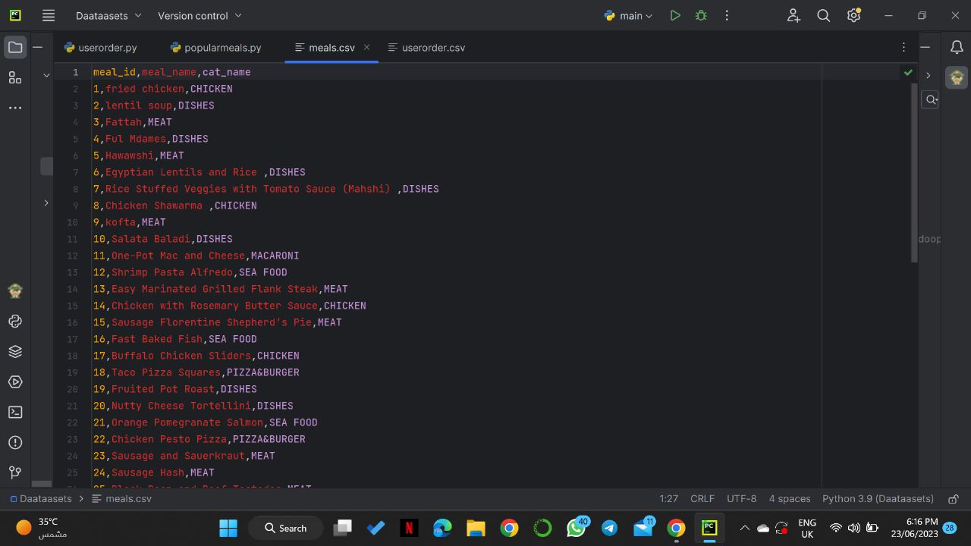

**for user-orders**

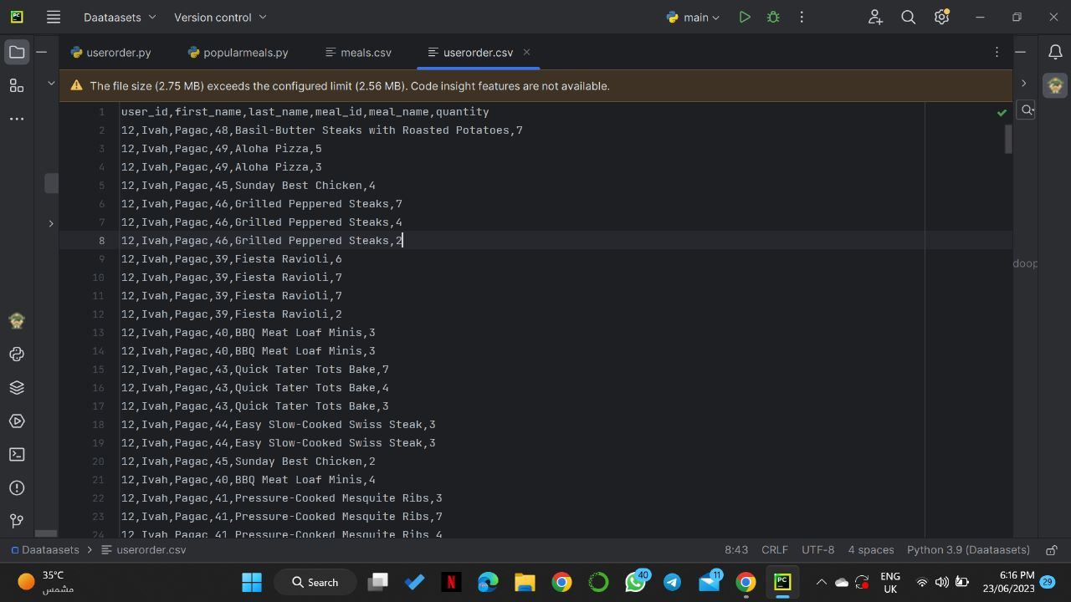

### The Database Management System

The database management system (DBMS) is software provided by the database vendor. software products such as Microsoft Access, Oracle, Microsoft SQL Server, Sybase ASE, DB2, Ingres, and MySQL are all DBMSS

If it seems odd to you that the DBMS acronym is used instead of merely DMS, remember that the term database was originally written as two words, and by convention has since become a single compound word.

The DBMS provides all the basic services required to organize and maintain the database , including the following

* Moves data to and from the physical data files as needed.
* Manages concurrent data access by multiple users, including provisions to prevent simultaneous updates from conflicting with one another.
* Supports a query language, which is a system of commands that a

database user employs to retrieve data from the database.

* Provides provisions for backing up the database and recovering from failures.
* Provides security mechanisms to prevent unauthorized data access and modification

A data bank and a database are the same thing. Data bank is merely an older term that was used by the scientists who developed early database systems. In fact, the term data bank is still used in a few human languages

### Layers of Data Abstraction

A user in this context is any person or application that signs on to the database for the purpose of storing and/or retrieving data

The architecture shown in Figure-1 was first developed by ANSI/SPARC (American National Standard Institute/Standards Planning and Requirements Committee) in the 1970s and quickly became a foundation for much of the database research and development efforts that followed. Most modern DBMSs follow this architecture, which is composed of three primary layers: the physical layer, the logical layer, and the external layer.

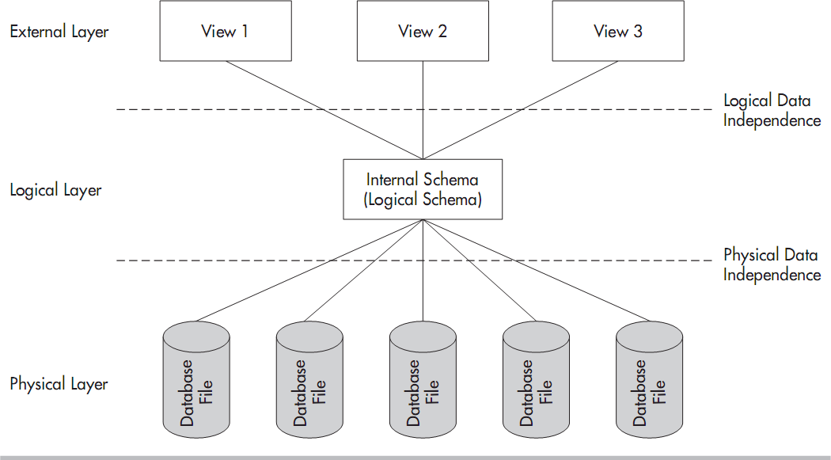

Figure 1

## **The Physical Layer**

The physical layer contains the data files that hold all data for the database

## **The Logical Layer**

The logical layer or logical model comprises the first of two layers of abstraction in the database: the physical layer has a concrete existence in the operating system files, whereas the logical layer exists only as abstract data structures assembled from the physical layer as needed.

## **The External Layer**

The database. This layer is composed of the external layer or external modelis the second user views, layer of abstraction in the

## **Physical Data Independence**

the ability to alter the physical file structure of database without disrupting exiting users and processes is known as physical data independence here are some examples of physical changes that can be made in a data-independent manner:

* Moving a database data file from one device to another or one directory to another
* Splitting or combining database data files
* Renaming database data files
* Moving a database object from one data file to another
* Adding new database objects or data files

## **Logical Data Independence**

the ability to make changes to logical layer without disrupting existing users and process is called logical data independence here are some examples of changes in the logical layer that can be safely made thanks to logical data independence:

* Adding a new database object
* Adding data items to an existing object
* Making any change in which a view can be placed in the external model that replaces (and processes the same as) the original object in the logical layer, such as combining or splitting existing objects

# Prevalent Database Models

A database model is essentially the architecture that the DBMS uses

to store objects within the database and relate them to one another

## **The Hierarchical Model**

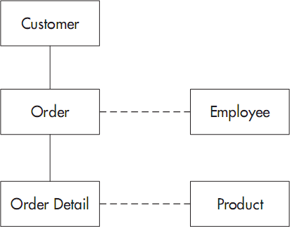The earliest databases followed the hierarchical model, which evolved from the file systems that the databases replaced, with records arranged in a hierarchy much like an organization chart

## Figure 2 **The Hierarchical Model Fig**

**A Network Model**

A network model is a database model that is designed as a flexible approach to representing objects and their relationships. A unique feature of the network model is its schema, which is viewed as a graph where relationship types are arcs and object types are nodes.

Unlike other database models, the network model's schema is not confined to be a lattice or hierarchy; the hierarchical tree is replaced by a graph, which allows for more basic connections with the nodes.

## **The Relational Model**

The relational model for database management is an approach to logically represent and manage the data stored in a database. In this model, the data is organized into a **collection of two-dimensional inter-related tables**, also known as **relations**. Each relation is a collection of columns and rows, where the column represents the attributes of an entity and the rows (or tuples) represents the records.

The use of tables to store the data provided a straightforward, efficient, and flexible way to store and access structured information. Because of this simplicity, this data model provides easy data sorting and data access. Hence, it is used widely around the world for data storage and processing.

## Relational Model Example

Figure 3

## 

## **Advantages of using the relational model**

The advantages and reasons due to which the relational model in DBMS is widely accepted as a standard are:

* **Simple and Easy To Use -** Storing data in tables is much easier to understand and implement as compared to other storage techniques.
* **Manageability -** Because of the independent nature of each relation in a relational database, it is easy to manipulate and manage. This improves the performance of the database.
* **Query capability -** With the introduction of relational algebra, relational databases provide easy access to data via high-level query language like SQL.
* **Data integrity -** With the introduction and implementation of relational constraints, the relational model can maintain data integrity in the database

**Disadvantages of using the relational model**

The main disadvantages of relational model in DBMS occur while dealing with a huge amount of data as:

* The performance of the relational model depends upon the number of relations present in the database.
* Hence, as the number of tables increases, the requirement of physical memory increases.
* The structure becomes complex and there is a decrease in the response time for the queries.
* Because of all these factors, the cost of implementing a relational database increase.

**Introduction to Data analysis**

## **Overview About data analytics**

Most companies are collecting loads of data all the time—but, in its raw form, this data doesn’t really mean anything. This is where data analytics comes in.

Data analytics is: **the process of analyzing raw data in order to draw out meaningful, actionable insights**, which are then used to inform and drive smart business decisions.

A data analyst will extract raw data, organize it, and then analyze it, transforming it from incomprehensible numbers into coherent, intelligible information. Having interpreted the data, the data analyst will then pass on their findings in the form of suggestions or recommendations about what the company’s next steps should be.

You can think of data analytics as a form of business intelligence, used to solve specific problems and challenges within an organization. It’s all about finding patterns in a dataset which can tell you something useful and relevant about a particular area of the business—how certain customer groups behave, for example, or how employees engage with a particular tool.

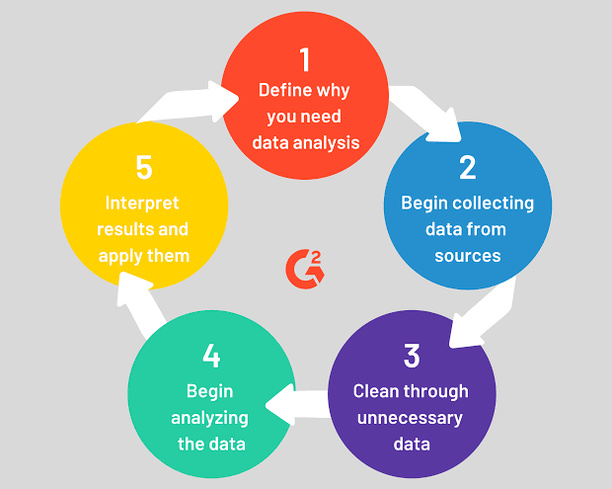

Figure 4

## **Main steps that a data analyst will follow**

the five main steps that a data analyst will follow when tackling a new project:

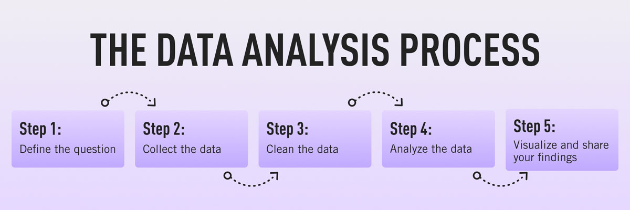

Figure5

### Step 1: Define the question(s) you want to answer

The first step is to identify **why you are conducting analysis** and **what question or challenge you hope to solve**. At this stage, you’ll take a clearly defined problem and come up with a relevant question or hypothesis you can test. You’ll then need to identify what kinds of data you’ll need and where it will come from

### Step 2: Collect the data

With a clear question in mind, you’re ready to **start collecting your data**. Data analysts will usually gather structured data from primary or internal sources, such as CRM software or email marketing tools. They may also turn to secondary or external sources, such as [**open data sources**](https://datatovalue.co.uk/top-21-open-data-sources/). These include government portals, tools like [**Google Trends**](https://trends.google.com/trends/?geo=US), and data published by major organizations such as UNICEF and the World Health Organization.

### Step 3: Clean the data

Once you’ve collected your data, you need to get it ready for analysis—and this means **thoroughly cleaning your dataset**. Your original dataset may contain duplicates, anomalies, or missing data which could distort how the data is interpreted, so these all need to be removed.

### Step 4: Analyze the data

Now for the actual analysis! How you **analyze the data** will depend on the question you’re asking and the kind of data you’re working with, but some common techniques include regression analysis, cluster analysis, and time-series analysis (to name just a few).

### Step 5: Visualize and share your findings

This final step in the process is where **data is transformed into valuable business insights**. Depending on the type of analysis conducted, you’ll present your findings in a way that others can understand—in the form of a chart or graph, for example.

**Chapter ( 2 )**

**Introduction to Web Design using AI technic**

**Overview About web design**

Web design is the creation of websites and pages to reflect a company’s brand and information and ensure a user-friendly experience. Appearance and design are incorporated as vital elements whether you’re designing a website, mobile app or maintaining content on a web page. Gaining web design skills can help you in applying for roles where your creativity could help a business improve their brand, their message and their bottom line.

**The elements of web design**

There are many standard components of every web design, including:

1. **Layout**

The layout of the website is how the material is displayed on a page. Choosing the layout is an essential task for the designer. It should be simple, intuitive and accessible. Web designers can use blank areas called white spaces to organize the elements of the site with grid-based designs to keep them in order.

1. **Images**

Images are illustrations, graphics, photographs, icons and others used to provide supplementary information to the text. To create the effect desired, designers can pick images that complement each other and the brand that the website represents.

1. **Visual hiararchy**

Visual hierarchy is the order in which the user will process the information on the site. The designer creates it by applying a visual pattern to the website. The visual pattern is the way the design directs visitors' eyes and behaviors.

1. **Color scheme**

The color scheme is a combination of colors that is in harmony with the brand and industry it represents. To achieve this, they will pick a dominant color and a few others to create a palette.

1. **Typography**

The typography is the style or font of the written content. Web designers pick one or a combination that is attractive and easy to read. To make the best choice, they should choose a font that corresponds to the target audience.

1. **Readability**

Readability is when the text of content is easy to see and read on a webpage. The text on the website should be readable because visitors usually spend little time on it and should find information quickly.

1. **Navigation**

The navigational elements are the tools allowing users to choose where they want to go within a website.

1. **Content**

Content is all of the information available on the website. It is a pivotal element because visitors want to get information quickly. When the website communicates clearly and grabs the readers' attention, it is more likely to convert them into consumers.

**Design Process**

Web design identifies the goals of a website or webpage and promotes accessibility for all potential users. This process involves organizing content and images across a series of pages and integrating applications and other interactive elements.

The professionals who perform this process are called web designers, and their job includes the following duties:

* Selecting easy-to-read fonts
* Choosing attractive color schemes that also enable easy-to-read fonts
* Creating a map of the website's structure to ensure intuitive navigation
* Placing images, logos, text, videos, applications and other elements
* Using coding languages, such as HTML and CSS, to create layouts and to style pages
* Making optimized versions of websites and pages both for desktop and mobile viewing

**Web Design using AI technic**

Chatbots are a type of artificial intelligence (AI) technology that can simulate conversations with humans. They are designed to understand natural language input from users and generate appropriate responses based on pre-defined rules or machine learning algorithms. Chatbots can be integrated with AI technologies to enhance their capabilities and improve their performance.

**How chatbots merges with AI:-**

One way chatbots merge with AI is by using machine learning algorithms to improve their natural language processing (NLP) capabilities. NLP is the ability of a computer program to understand human language, including the meaning and context of words and phrases. By using machine learning algorithms, chatbots can learn from user interactions and improve their ability to understand and respond to natural language input.

Another way chatbots merge with AI is by using natural language generation (NLG) technology to generate humanlike responses. NLG is the ability of a computer program to generate natural language text based on structured data or rules. By using NLG technology, chatbots can generate more sophisticated and personalized responses to user input, improving the overall user experience.

Chatbots can also be integrated with other AI technologies, such as computer vision, to enhance their capabilities. For example, a chatbot integrated with computer vision technology can analyze images or videos and provide relevant information to users based on their input.

Additionally, chatbots can be integrated with AI-powered analytics tools to analyze user data and provide insights into user behavior and preferences. By analyzing user data, chatbots can personalize their responses and improve their ability to provide relevant information to users.

Overall, integrating chatbots with AI technologies can enhance their capabilities and improve their performance. By using machine learning algorithms, natural language generation technology, computer vision, and analytics tools, chatbots can provide more personalized and sophisticated responses to users, improving the overall user experience.

**Types of chatbots :-**

There are several types of chatbots, each with its own characteristics and functionalities. The three main types of chatbots are rule-based chatbots, AI-powered chatbots, and hybrid chatbots.

**Rule-Based Chatbots:**

Rule-based chatbots are the simplest type of chatbots. They are programmed to follow a set of pre-defined rules and can only respond to specific commands or questions. They work by matching user input to a set of pre-defined rules and generating a response based on those rules. Rule-based chatbots are effective for handling simple and straightforward tasks, such as providing basic information or answering frequently asked questions.

**AI-Powered Chatbots:**

AI-powered chatbots are more sophisticated than rulebased chatbots. They use machine learning algorithms and natural language processing (NLP) to understand and respond to user input. AI-powered chatbots can learn from user interactions and improve their responses over time. They can handle more complex tasks and provide personalized responses to users based on their input and preferences. Also this type uses specific data set to response for customer question .

**Hybrid Chatbots:**

Hybrid chatbots combine the functionalities of rule-based chatbots and AI-powered chatbots. They use a combination of pre-defined rules and machine learning algorithms to understand and respond to user input. Hybrid chatbots can handle both simple and complex tasks and provide more accurate and personalized responses to users.

**Other types of chatbots include:**

Task-Oriented Chatbots: Task-oriented chatbots are designed to perform specific tasks, such as booking a flight or ordering food. They are programmed to follow a set of pre-defined steps to complete the task.

Conversational Chatbots: Conversational chatbots are designed to simulate human conversation. They use NLP and machine learning algorithms to understand and respond to user input in a natural and conversational way.

Social Media Chatbots: Social media chatbots are designed to interact with users on social media platforms, such as Facebook or Twitter. They can handle tasks such as answering customer queries and providing customer support.

Voice-Enabled Chatbots: Voice-enabled chatbots are designed to respond to voice commands. They are commonly used in virtual assistants, such as Amazon Alexa or Apple Siri.

And we uses the type of AI-powered chatbot because it uses specific data set at response to questions and driven through machine learning algorithm.

**Recommendation**

Recommendations in AI chatbots refer to the process of suggesting products, services, or actions to users based on their preferences and behavior. AI chatbots can use various techniques to provide personalized recommendations, such as collaborative filtering, content-based filtering, and hybrid filtering.

Collaborative filtering is a commonly used technique in recommendation systems that analyzes the behavior of users with similar preferences and recommends products or services based on their choices. Content-based filtering, on the other hand, uses the attributes of a product or service to recommend similar items to users who have shown an interest in that particular type of content.

Hybrid filtering combines both collaborative and content-based filtering techniques to provide more accurate and personalized recommendations. This approach takes into account the user's behavior as well as the attributes of the products or services they interact with.

AI chatbots can also use reinforcement learning algorithms to improve their recommendations over time. This involves learning from user feedback and adjusting the recommendations accordingly.

Overall, recommendations in AI chatbots can improve the user experience by providing personalized suggestions that are relevant to their interests and needs.

**How can chatbots use reinforcement learning to improve recommendations?**

Reinforcement learning is a type of machine learning that involves an agent learning to make decisions based on feedback from its environment. In the context of chatbots, reinforcement learning can be used to improve recommendations by allowing the chatbot to learn from the actions and feedback of users.

**Here's an example of how a chatbot can use reinforcement learning to improve recommendations:**

The chatbot starts by making a recommendation based on the user's input.

The user then provides feedback on whether they liked or disliked the recommendation.

The chatbot uses this feedback to adjust its recommendation algorithm. For example, if the user liked the recommendation, the chatbot can increase the weight of the features that led to that recommendation. Conversely, if the user disliked the recommendation, the chatbot can decrease the weight of those features.

The chatbot then makes another recommendation based on the adjusted algorithm.

The process is repeated, with the chatbot learning and adjusting its recommendations based on user feedback.

Over time, the chatbot can use reinforcement learning to improve the accuracy and relevance of its recommendations, based on the preferences and behaviors of individual users. This can lead to higher user satisfaction and engagement with the chatbot, as well as increased sales and revenue for businesses using the chatbot for customer service or sales purposes.

**How can chatbots ensure user privacy while using reinforcement learning?**

Ensuring user privacy is an important consideration when using reinforcement learning in chatbots. Here are some ways that chatbots can protect user privacy while using reinforcement learning:

Use anonymized data: Chatbots can be designed to collect and store only anonymized data, which means that the user's personal information is not linked to their interactions with the chatbot. This can help protect user privacy while still allowing the chatbot to learn from user feedback.

Implement data security measures: Chatbots can use encryption and other data security measures to protect user data from unauthorized access or misuse. This can include measures such as data encryption during storage and transmission, data access controls, and regular security audits.

Obtain user consent: Chatbots can obtain user consent before collecting or using any personal data. This can help ensure that users are aware of how their data is being used and can opt-out if they are uncomfortable with sharing their information.

Provide transparency: Chatbots can be designed to be transparent about their data collection and use practices. This can include providing clear information on how data is collected, how it is used, and who has access to it.

Allow users to delete their data: Chatbots can provide users with the ability to delete their data if they no longer wish to use the chatbot or if they want to remove their data from the chatbot's database.

By implementing these measures, chatbots can ensure that user privacy is protected while still being able to use reinforcement learning to improve their recommendations.

**here are some additional details about how chatbots can make recommendations:**

Contextual information: Chatbots can use contextual information to provide more personalized recommendations. For example, if a user is chatting with a travel chatbot and mentions that they are interested in beach vacations, the chatbot can recommend destinations that are known for their beaches.

User history: Chatbots can use a user's history of interactions and behavior to make recommendations. For example, if a user has previously purchased a certain type of product or service, the chatbot can recommend similar items or services.

Natural language processing: Chatbots can use natural language processing (NLP) to understand user input and provide more accurate recommendations. For example, if a user asks a food chatbot for a recommendation for a romantic dinner, the chatbot can use NLP to understand the user's intent and provide relevant recommendations.

Personalization: Chatbots can use personalization techniques to tailor recommendations to individual users. This can include factors such as past behavior, demographics, and psychographics.

Multi-channel recommendations: Chatbots can provide recommendations across multiple channels, such as email, social media, and messaging platforms. This can increase the reach of the chatbot and provide users with recommendations in the channels they prefer.

Overall, chatbots can use a variety of techniques and data sources to provide personalized recommendations to users. By using these techniques, chatbots can improve the user experience, increase engagement, and drive business results.

**examples of recommendation by chatbots :**

E-commerce chatbots: E-commerce chatbots can recommend products to users based on their browsing and purchase history. For example, if a user has previously purchased running shoes, the chatbot can recommend other running-related products such as running clothes, fitness trackers, or energy gels.

Travel chatbots: Travel chatbots can recommend destinations, flights, hotels, and activities to users based on their preferences and travel history. For example, if a user has previously booked beach vacations, the chatbot can recommend beach destinations that are similar to the user's previous trips.

Food chatbots: Food chatbots can recommend restaurants, recipes, and meal delivery services to users based on their dietary preferences and location. For example, if a user is looking for vegan restaurants in a certain area, the chatbot can recommend vegan-friendly restaurants in that area.

Financial chatbots: Financial chatbots can recommend investment products and financial services to users based on their investment goals and risk tolerance. For example, if a user is looking to invest in low-risk stocks, the chatbot can recommend a portfolio of low-risk stocks based on the user's investment preferences.

Customer service chatbots: Customer service chatbots can recommend solutions to users based on their issue or question. For example, if a user is experiencing a technical issue, the chatbot can recommend troubleshooting steps or connect the user with a technical support representative.

Overall, chatbots can provide personalized recommendations to users across a variety of industries and use cases, improving the user experience and driving business results.

and we use Collaborative filter that based on previous data .

**and the following is the data that recommendation based on it :-**

**for user-orders**



**Meals with Categories:-**



**Chapter ( 3 )**

* **Abstract**

Our System is a website designed primarily for use in the healthy food delivery industry. This system will allow to quickly and easily manage an online menu which customers can browse and use to place orders with just a few clicks.

The system also provides job opportunities for housewives

* **Function Requirements**
* System enable user to register for first time and create his account.
* After the chefs are accepted the admin will add them to the application
* user add all his personal information and he can update this information at any time.
* Then each chef adds the meal and meal details (image, price, details).
* The chef can add or remove or update the meal.
* Customer make registration in the application in this process he add all his personal information he can update this information at any time.
* Customer can see all meal or select certain meals according to categories or search about certain meal by name of the meal.
* Customer can add meal to his cart and can remove it again if he want that.
* After customer add all meals he can make order and pay with two methods cash or with credit card.
* Customer can cancel the order (order not shipped).
* After the order is confirmed he will know all details about his shipment
* Then the customer to rate the meal after receiving it.
* If customer want quick ask about any information about meal he can use chat bot.
* Admin can add or remove the chef and make report about best chef , bestselling meal and Most Distinguished Client.
* **Non-Functional Requirements**
* **Usability :-**
* A customer should easily find the right products for them understand what problems are solves and make a purchase without contacting us
* No multistep checkout : users must reach the “add to cart” button in one step
* **Security :-**
* only the system data administrator can assign roles and change access permissions to the system
* the website must be resilient to any kind of attack
* **Performance :-**
* the website’s homepage should load in a few time
* **Maintainability :-**
* Because we are looking to grow , the website shall remove all the back-end complexities for in-house engineers to changes to the systems in the future

**Environment :-**

* **Hardware:-**
* Processor : 1GHZ or faster
* RAM : 1 GB or 2GB
* Graphics : direct x9 or latter with WDDM 1.0 driver
* Display : 800*600 resolution
* **Software:-**
* **Languages**
* HTML / HTML5
* CSS / CSS3
* JAVASCRIPT
* Bootstrap ( Library)
* Wow js (Library)
* VueJs ( Framework)
* Python
* Django
* **Tools**
* VS Code
* Adobe XD
* Postgsql
* Pg Admin

### Problem & Solution

* **Problem**

Some people have problems with fast food and ready meals, such As

* Lack of trust in restaurant sources
* Inadequate hygiene and awareness
* Not wanting to eat meals made outside the home
* **Solution**

Create a Website that links the provision of demand for all home

food and the provision of the best home chefs Lack of trust in restaurant sources

* Provide all categories of home food
* Provide better services
* Connect with available home chefs

### System Functions

* Register
* Login
* View Meals
* Search for Chiefs and Meals
* Check Arability for Meals
* Display Cart Item details
* Add items to cart item
* Remove Items from Cart Item
* Make order
* Make Payment
* Order Canceled
* Check Order statue
* Post Feedback
* Chat Online
* Deliveryman track
* Update customer info
* Logout
* Add new meal
* View Voucher
* Add Chief
* Remove Chief
* Add & View rate
* Update Order Details
* Respond Chat
* Replay Feedback
* View Shipment
* **Survey**

I carried out a survey and interviews to understand the pain points of the users. I interviewed 3 people who make use of food delivery services also i having gotten 195 responses in the survey form

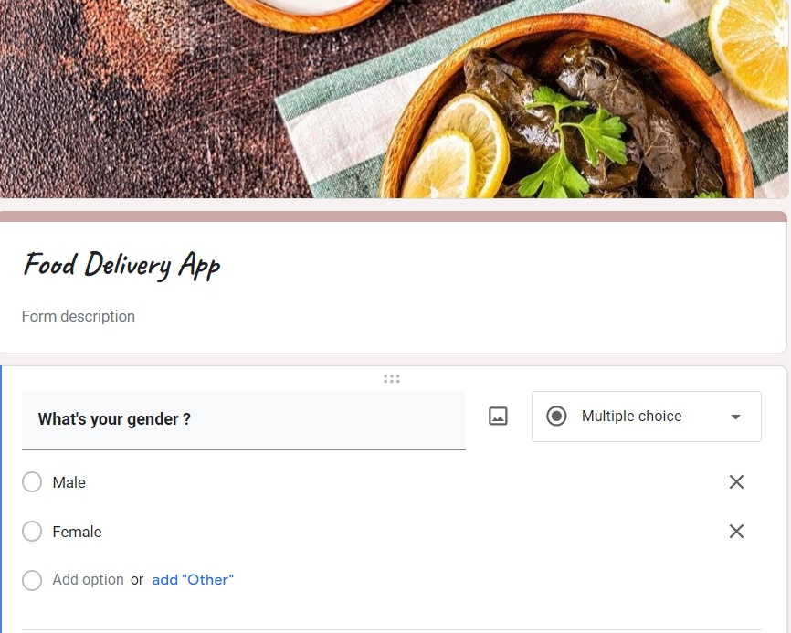

Figure 6

* **Survey Results**

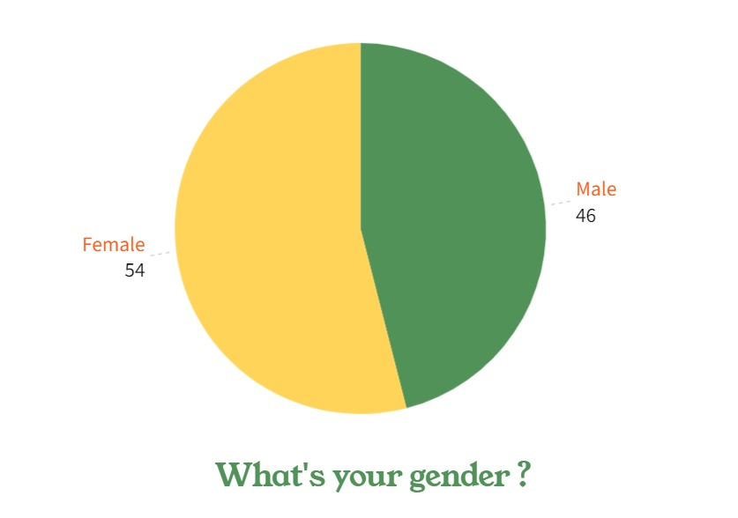

Figure 7

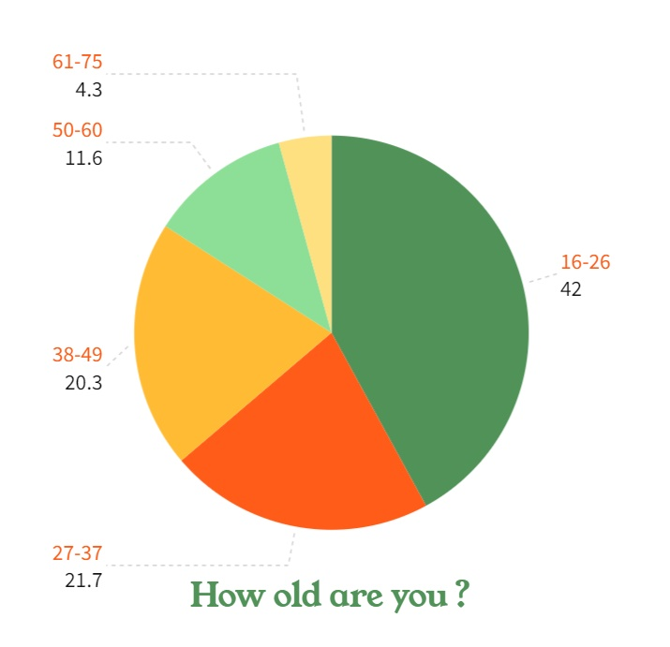

Figure 8

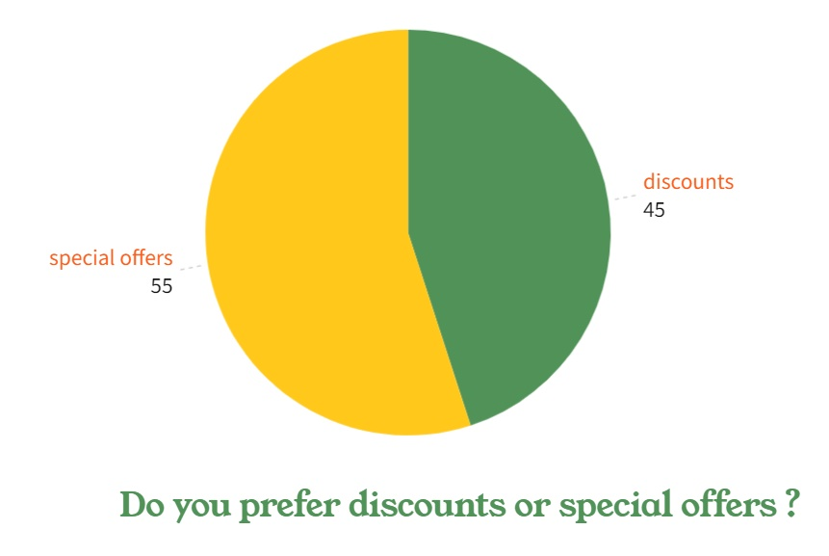

Figure 9

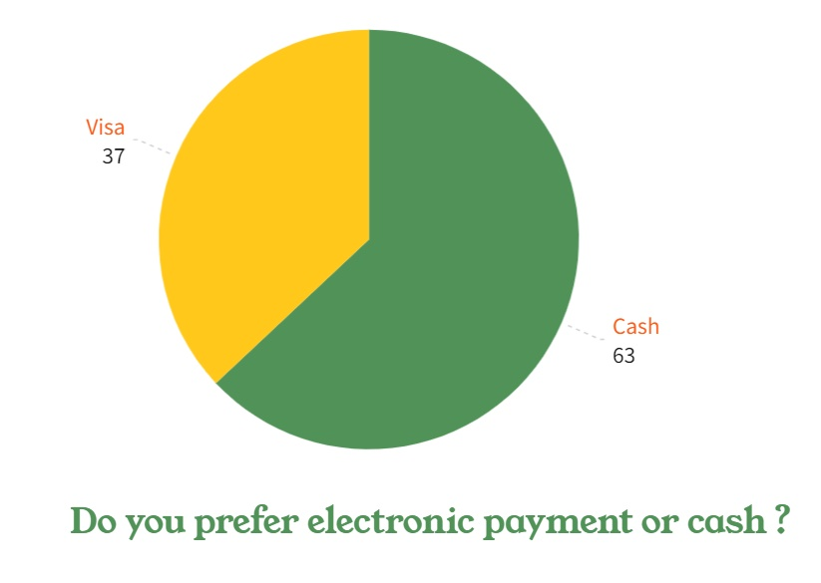

Figure 10

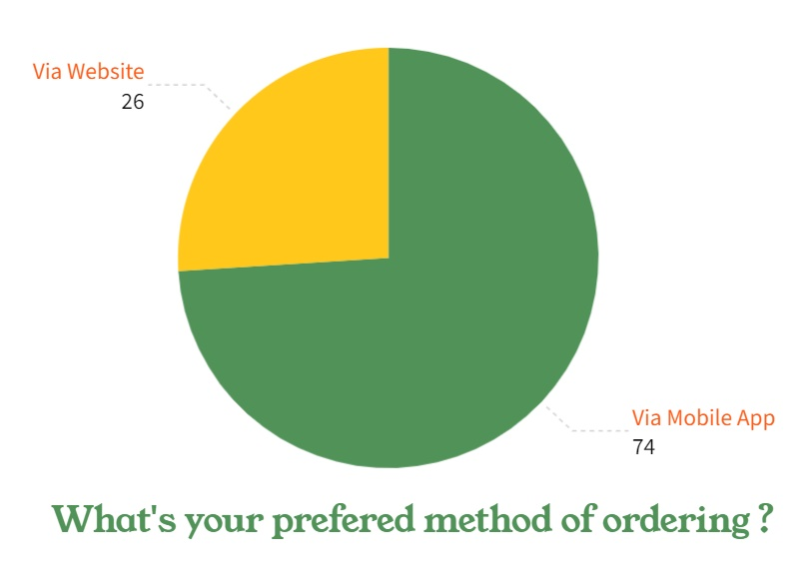

Figure 11

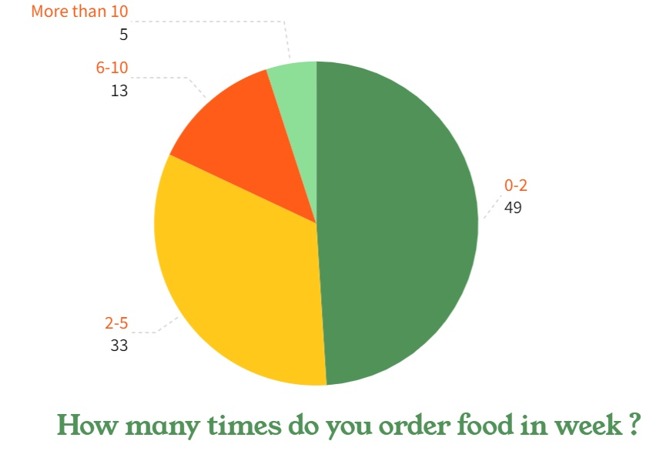

Figure 12

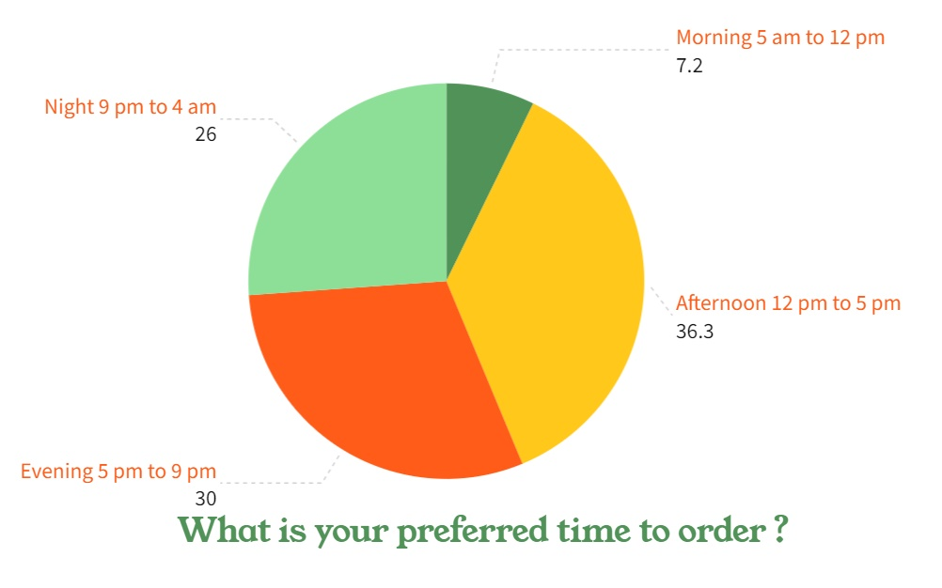

Figure 13

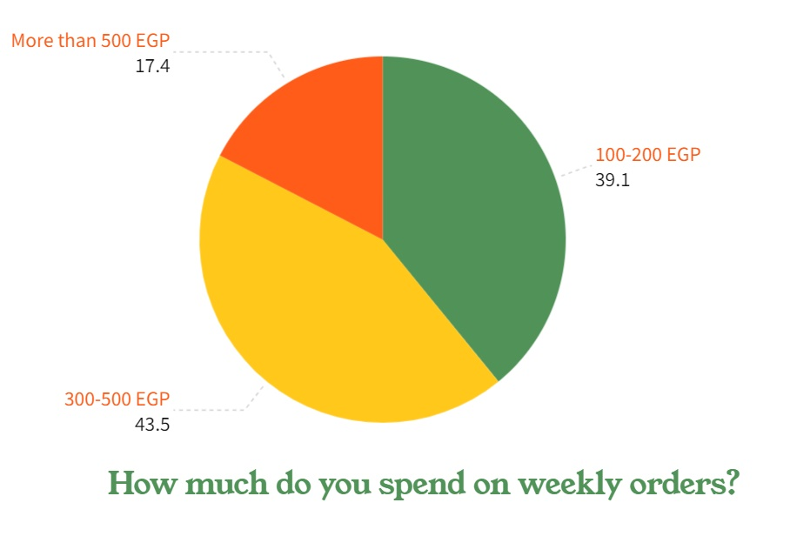

Figure 14

* **ERD**

Figure 15 ERD

* **Schema**

Figure 16 schema

* **Use Case Description**

|  |  |
| --- | --- |
| Use case name: admin login | |
| Use case number | Uc-01 |
| Use case description | Admin login to dashboard |
| Actor | Admin |
| Pre-condition | The person how try to enter is must already his role is admin |
| Sequence of event | -admin open login page  -enter his email  -enter his password  -click login button  -dashboard of admin will open |
| Post condition | Admin can manage system |
| Exception | -admin entered a wrong email  - admin entered a wrong password  -user is not admin |

|  |  |
| --- | --- |
| Use case name: add a new admin | |
| Use case number | Uc-02 |
| Use case description | supper admin can add new admin |
| Actor | Supper admin |
| Pre-condition | System need an new admin |
| Sequence of event | -supper admin add the information of new admin (first name – second name- email -password- city)  -Account will create |
| Post condition | Admin become have account |
| Exception | Supper admin enter wrong or invalid data |

|  |  |
| --- | --- |
| Use case name: update user information | |
| Use case number | Uc-03 |
| Use case description | user can update his personal information |
| Actor | Admin, chef ,deliveryman, customer |
| Pre-condition | The user must be already registered on system |
| Sequence of event | -user go to his profile  -user go to update personal information part  -user can update his information (like change his phone, address, ...)  -System update user information |
| Post condition | user info have been updated successfully |
| Exception | user enter invalid information |

|  |  |
| --- | --- |
| Use case name: user logout | |
| Use case number | Uc-04 |
| Use case description | user logout from site |
| Actor | Admin, chef ,deliveryman, customer |
| Pre-condition | The user must be already login the system |
| Sequence of event | -user login the system  -user press on logout |
| Post condition | user logout  user can’t use the system |
| Exception | Error occur lose internet connection |

|  |  |
| --- | --- |
| Use case name: chef register | |
| Use case number | Uc-05 |
| Use case description | Enable chef to register for first time |
| Actor | chef |
| Pre-condition | chef has valid e-mail |
| Sequence of event | chef add his information (first name – second name- email -password- phone – city- address-gender- birthdate -nationality- certificate- experience)  -Account will create |
| Post condition | Chef become have account |
| Exception | Chef enter wrong or invalid data |

|  |  |
| --- | --- |
| Use case name: chef login | |
| Use case number | Uc-06 |
| Use case description | chef login to system |
| Actor | chef |
| Pre-condition | The person how try to enter is must already his role is chef |
| Sequence of event | -chef open login page  -enter his email  -enter his password  -click login button and page of chef will open |
| Post condition | Chef is waiting for the admin to accept him |
| Exception | -chef entered a wrong email  - chef entered a wrong password  -user is not chef |

|  |  |
| --- | --- |
| Use case name: accept new chef | |
| Use case number | Uc-07 |
| Use case description | Admin accept the new chef |
| Actor | Admin -chef |
| Pre-condition | System need to a new chef |
| Sequence of event | -the admin show the request and chick the data of chef  -the chef is accepted  -admin click add new chef  -admin add the new chef in the system  -admin click save button |
| Post condition | Chef can use the system and add his meals |
| Exception | chef already added |

|  |  |
| --- | --- |
| Use case name: chef add new meal | |
| Use case number | Uc-08 |
| Use case description | chef add new meal to system |
| Actor | chef |
| Pre-condition | The person how try to add a new meal is must already his role is chef |
| Sequence of event | -chef open add new meal page  -enter category of meal  -enter name of meal  -enter description of meal  -enter ingredient of meal  -enter warning of meal  -enter calories of meal if needed  -enter price of meal  -click save button |
| Post condition | Customer can buy this meal |
| Exception | chef entered a wrong or invalid data |

|  |  |
| --- | --- |
| Use case name: chef update meal | |
| Use case number | Uc-09 |
| Use case description | chef update the meal to system |
| Actor | chef |
| Pre-condition | The meal contains missing details and the chef wants to update it |
| Sequence of event | -chef open update the meal page  - click edit button  -chef do the edit  -click update button |
| Post condition | Customer can buy this meal after the update |
| Exception | -chef entered a wrong or invalid data  -chef didn’t save the edit |

|  |  |
| --- | --- |
| Use case name: chef delete the meal | |
| Use case number | Uc-10 |
| Use case description | chef delete the meal to system |
| Actor | chef |
| Pre-condition | The meal contains missing details and the chef wants to update it |
| Sequence of event | -chef open delete the meal page  - click delete button  -the meal was deleted |
| Post condition | The meal was deleted from the system and Customer can’t buy this meal |
| Exception | the meal is still on the system |

|  |  |
| --- | --- |
| Use case name: customer register | |
| Use case number | Uc-11 |
| Use case description | Enable customer to register for first time |
| Actor | Customer |
| Pre-condition | customer has valid e-mail |
| Sequence of event | customer add his information (first name – second name- email -password- phone – address-gender- birthdate - nationality)  -Account will create |
| Post condition | customer become have account |
| Exception | customer enter wrong or invalid data |

|  |  |
| --- | --- |
| Use case name: customer login | |
| Use case number | Uc-12 |
| Use case description | customer login to system |
| Actor | Customer |
| Pre-condition | The person how try to enter is must already his role is customer |
| Sequence of event | -customer open login page  -enter his email  -enter his password  -click login button  -page of customer will open |
| Post condition | customer can see all meals on system |
| Exception | -customer entered a wrong email  -customer entered a wrong password  -user is not customer |

|  |  |
| --- | --- |
| Use case name: view the meals | |
| Use case number | Uc-13 |
| Use case description | customer view the meals |
| Actor | Customer |
| Pre-condition | see all meals of all categories |
| Sequence of event | -Customer choose the meals he want by choose category  -System display meals that chosen by customer |
| Post condition | Only meals selected by customer will be viewed |
| Exception | category selected not available now |

|  |  |
| --- | --- |
| Use case name: search for meal | |
| Use case number | Uc-14 |
| Use case description | Customer search for specific meal |
| Actor | Customer |
| Pre-condition | All categories and meals appear |
| Sequence of event | -Customer search for specific meal by write its name or part of its name  -System display meals that chosen by customer |
| Post condition | The meal in which customer are looking for it will appear |
| Exception | -Misspelled when customer search for any meal  -meal not available |

|  |  |
| --- | --- |
| Use case name: display meal details | |
| Use case number | Uc-15 |
| Use case description | Show description for any meal |
| Actor | Customer |
| Pre-condition | Chef add details for meal |
| Sequence of event | - customer open meal page  - meal details will appear on the screen |
| Post condition | meal details will appear on the screen |
| Exception | meal removed |

|  |  |
| --- | --- |
| Use case name: add meal to cart item | |
| Use case number | Uc-16 |
| Use case description | Customer can add meal to cart item |
| Actor | Customer |
| Pre-condition | -cart empty  -cart include previously added meals |
| Sequence of event | -Customer see meal  -Customer add it to cart  -System display message indicate the meal added to cart item |
| Post condition | meal added to customer cart |
| Exception | meal removed by chef |

|  |  |
| --- | --- |
| Use case name: remove meal from cart item | |
| Use case number | Uc-17 |
| Use case description | Customer can remove meal from cart item |
| Actor | Customer |
| Pre-condition | Customer added meal to his cart |
| Sequence of event | -Customer go to cart  -Customer remove the product  -System display message indicate the meal removed from cart item |
| Post condition | meal removed from customer cart |
| Exception | Error occur only when lose internet connection |

|  |  |
| --- | --- |
| Use case name: checkout | |
| Use case number | Uc-18 |
| Use case description | Customer makes the order |
| Actor | Customer |
| Pre-condition | There are meals in cart item |
| Sequence of event | Customer go to cart  -Customer make order  - Customer go to payment process then make the order |
| Post condition | Customer ready to select the payment process |
| Exception | The meal isn’t available |

|  |  |
| --- | --- |
| Use case name: Make payment | |
| Use case number | Uc-19 |
| Use case description | Allow customer pay the price of the order |
| Actor | Customer |
| Pre-condition | -Order has been made  -Order statue is in progress not failed |
| Sequence of event | -Customer make order  -Case a pay cash  -Case b pay with credit card |
| Post condition | Payment process has been done and Customer ready to add the voucher |
| Exception | -In case of credit only ( credit card is not valid) -Balance of credit card < order value |

|  |  |
| --- | --- |
| Use case name: order | |
| Use case number | Uc-20 |
| Use case description | Customer order details |
| Actor | Customer |
| Pre-condition | Customer confirm the order |
| Sequence of event | -It will appear to the customer the date of order ,time of order, number of meals and total price  -customer in this case can cancel or confirm the order |
| Post condition | -if the customer cancelled the order the shipment will fail  -if the customer confirm the order he will transferred to the shipment process |
| Exception | Error occur only when lose internet connection |

|  |  |
| --- | --- |
| Use case name: order cancelled | |
| Use case number | Uc21 |
| Use case description | Customer cancel the order |
| Actor | Customer |
| Pre-condition | Customer confirm the order |
| Sequence of event | -Customer make order  -Customer cancel the order  -System display message indicate the order is canceled and choose the reason of why you cancel the order |
| Post condition | Order canceled |
| Exception | -There is no order made by customer  -Order time exceed the certain time  -Order already shipped |

|  |  |
| --- | --- |
| Use case name: post feedback | |
| Use case number | Uc-22 |
| Use case description | Customer confirm the order |
| Actor | Customer to rate the meal after receiving it |
| Pre-condition | Order has been delivered |
| Sequence of event | -Customer write a title of rate the meal  - Customer write a review of rate the meal  - Customer give a rate from 1 to 5 |
| Post condition | The meal take evaluated |
| Exception | -There is no order done by the customer  -meal or chef removed |

* **Use Case Diagram**

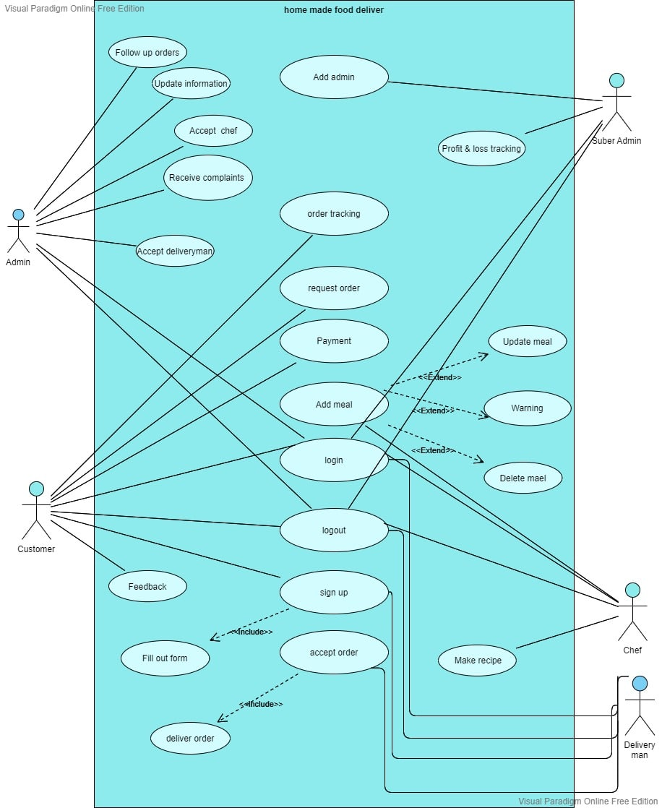

Figure 17 use case diagram

* **Bussiness Model**



Figure 18 business model

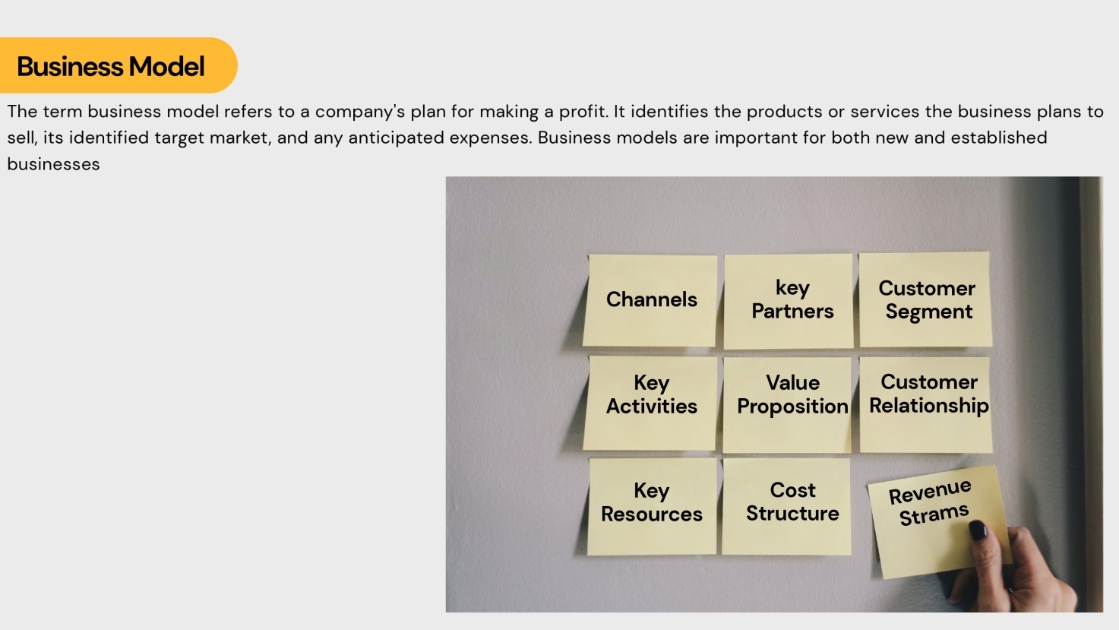

Figure 19

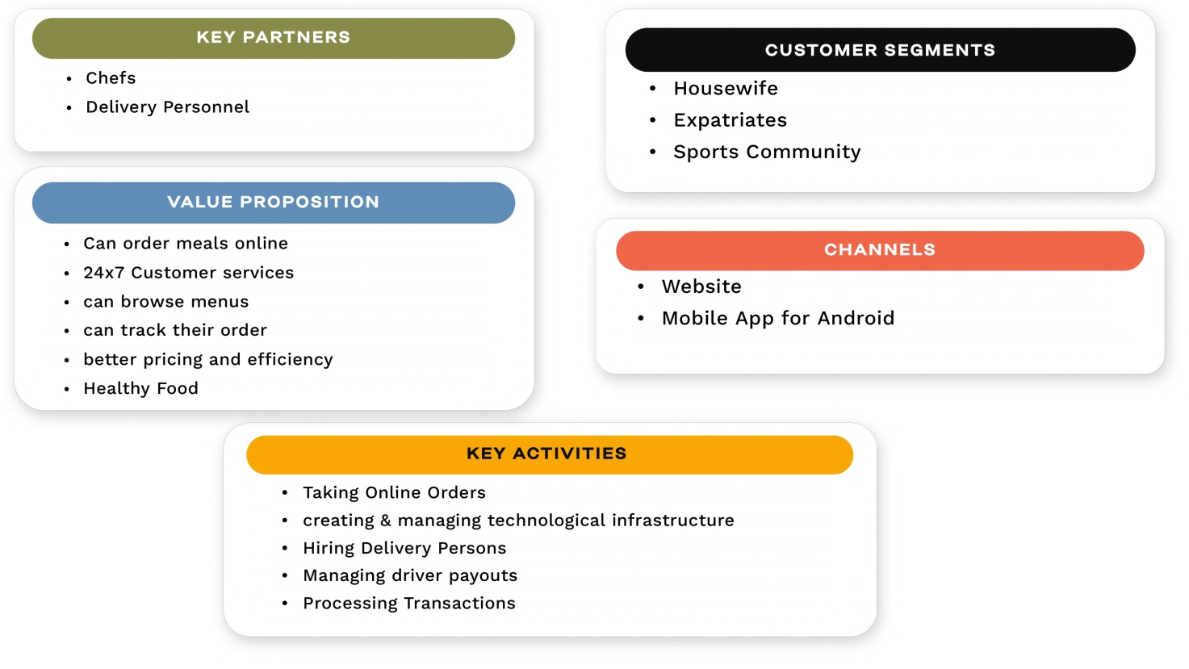

Figure 20

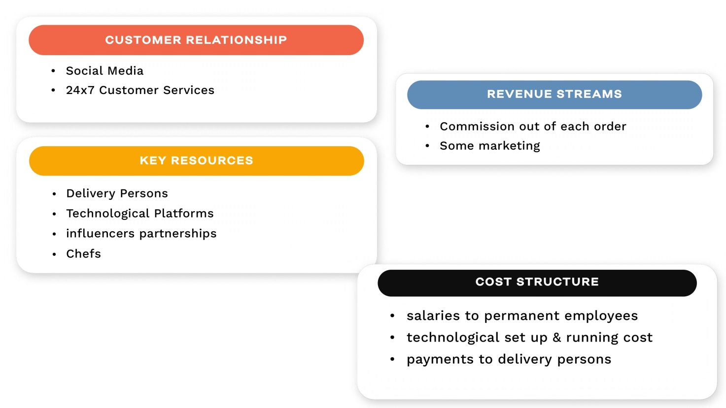

Figure 21

**Key partners :-**

For chefs : We appoint chefs based on their extensive experience in the field, and each chef can receive orders and add meals to the menu

For deliverymen : it another specific system could be done in future work .

**Value proposition :-**

System let users to enroll to it and make their accounts and order their own orders simply and choose a specific menu.

Besides healthy food would spread out between our community .

**Channels:-**

Our projects run via website through pages for users and chefs

**Customer Relationship:-**

We communicate with users through social media pages which have the same name of our website and same logo , to receive their own problems , ideas and thanks .

**Revenue streams :-**

Our revenue results appears in dash board of system in admins pages to make sure of our revenue

**Cost structure :-**

After receiving our own revenue we charge the delivery men, chefs and other workers

**Chapter ( 4 )**

**Testing verification and validation**



Figure 22



Figure 23

Figure 24

Figure 25

Figure 26

Figure 27

Figure 28

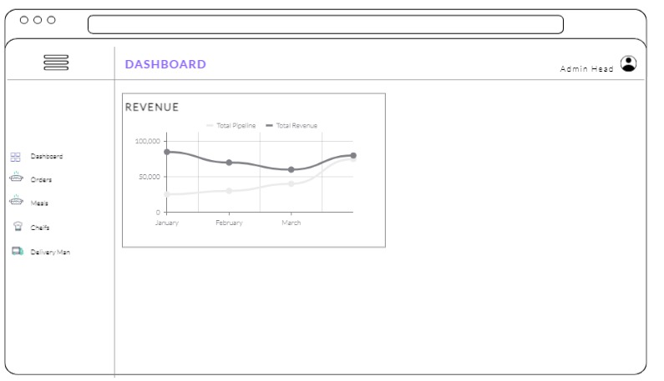

Figure 29

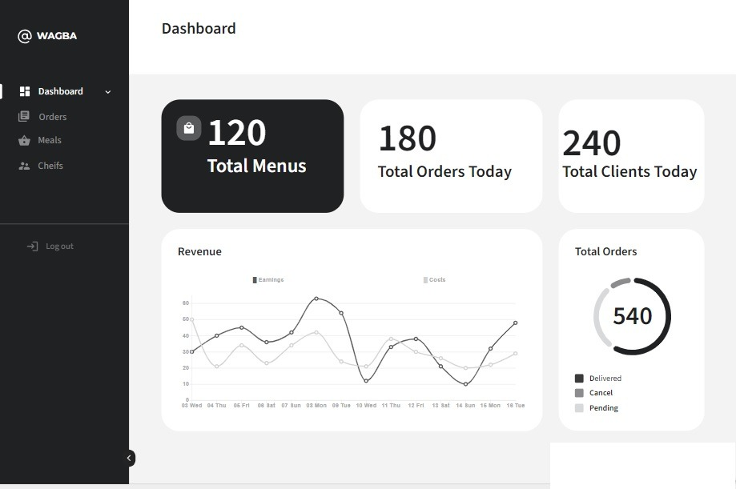

Figure 30

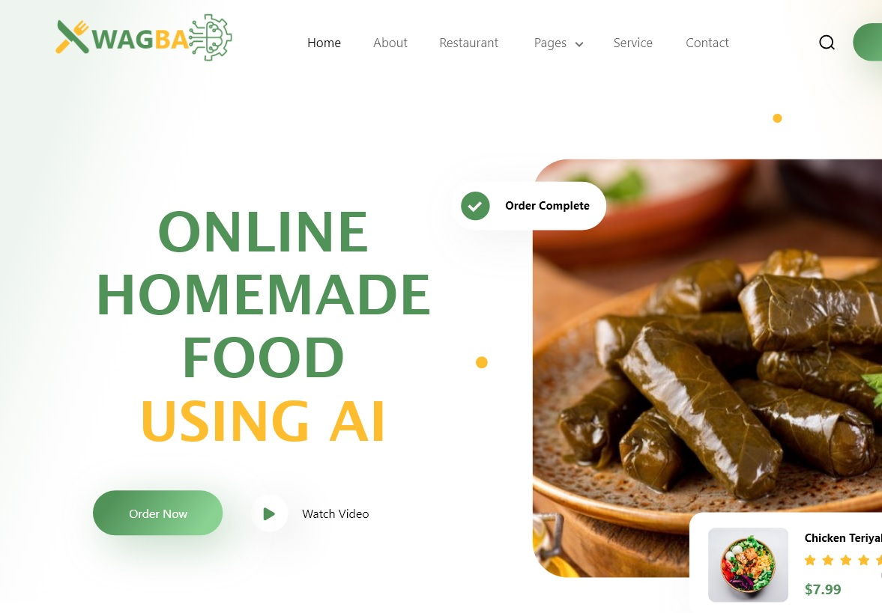

Figure 31

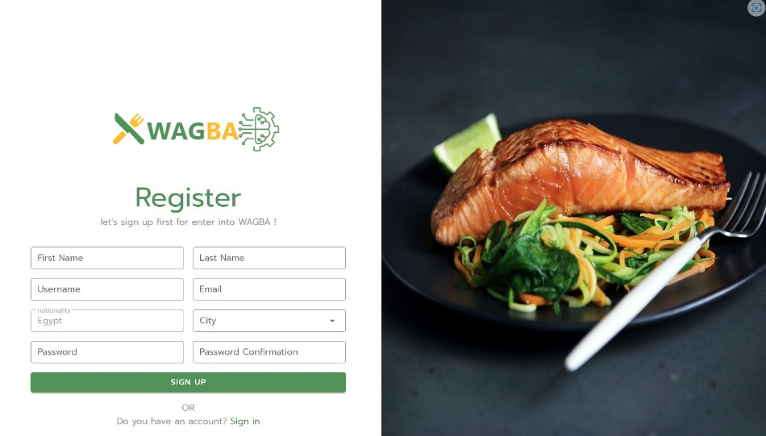

Figure 32

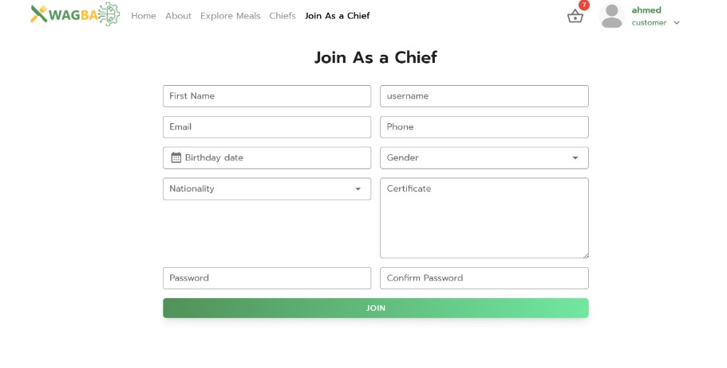

Figure 33

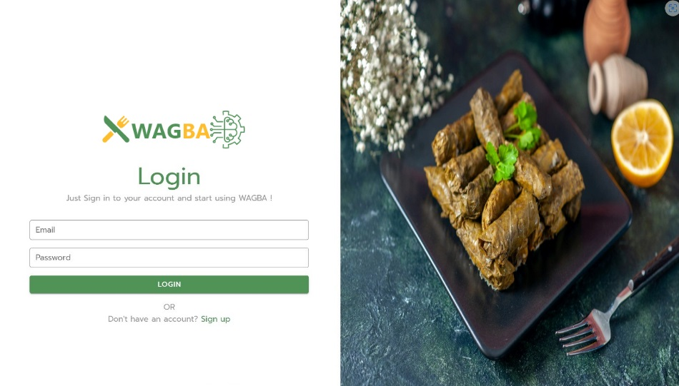

Figure 34



Figure 35

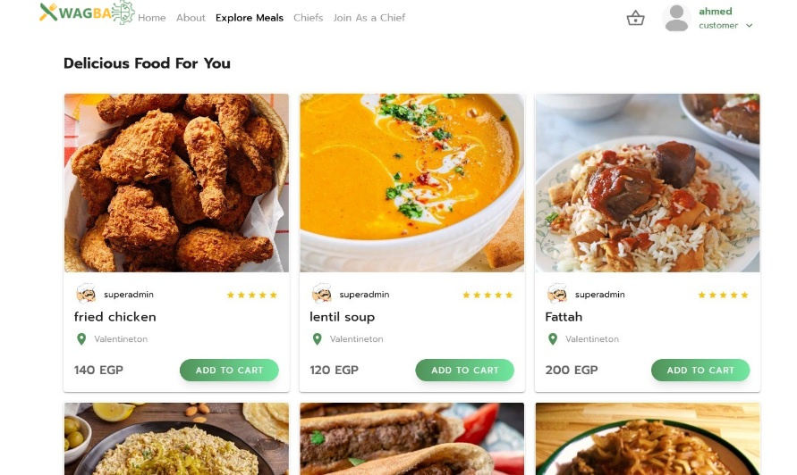

Figure 36

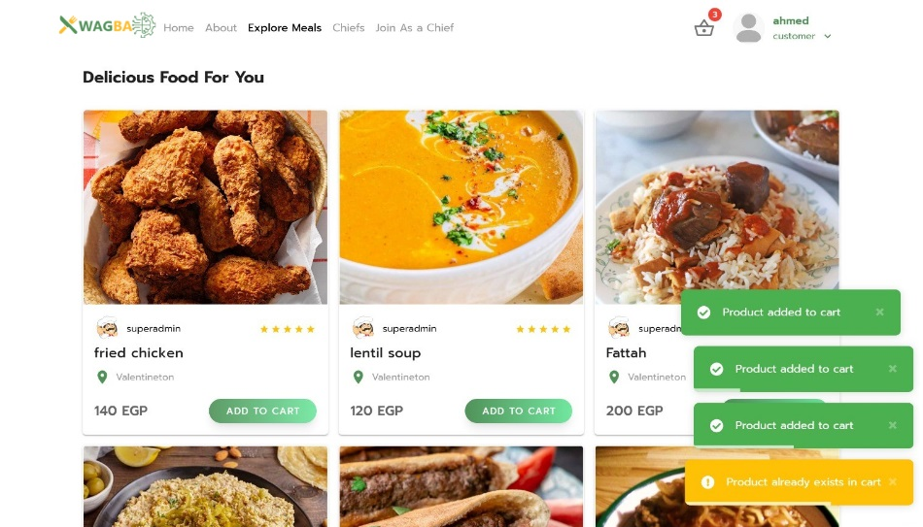

Figure 37

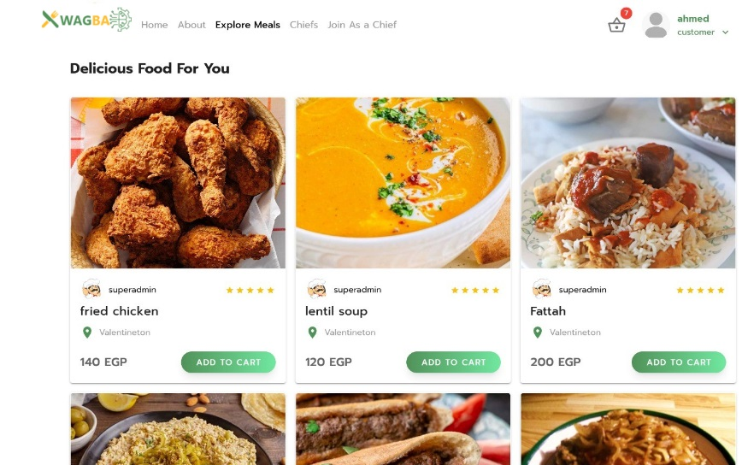

Figure 38

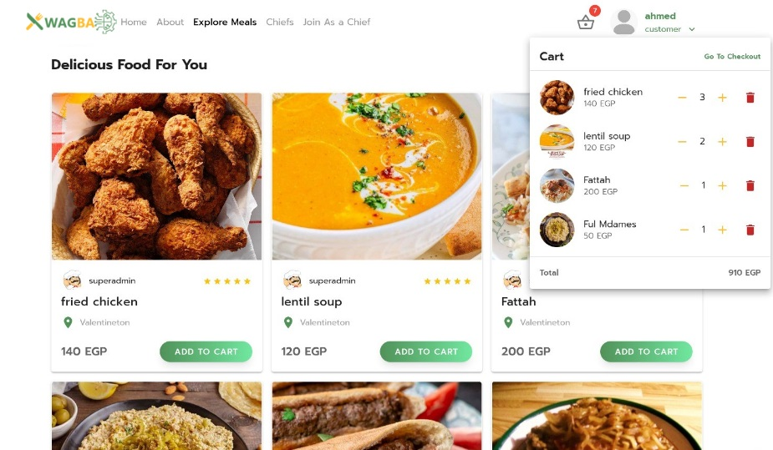

Figure 39



Figure 40

Figure 41

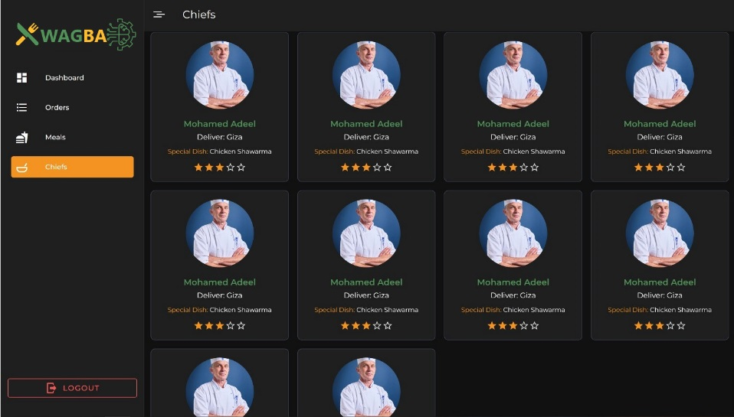

Figure 42

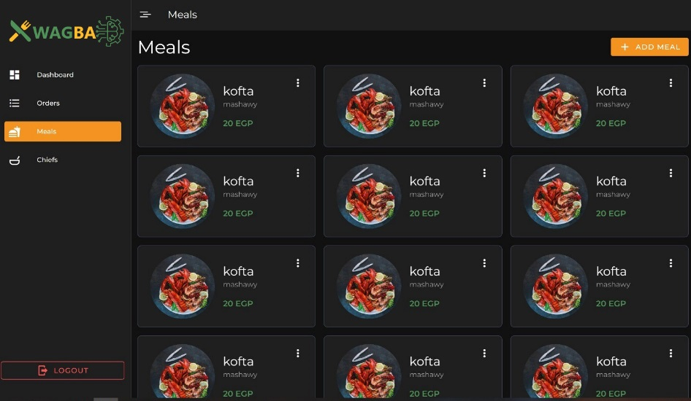

Figure 43

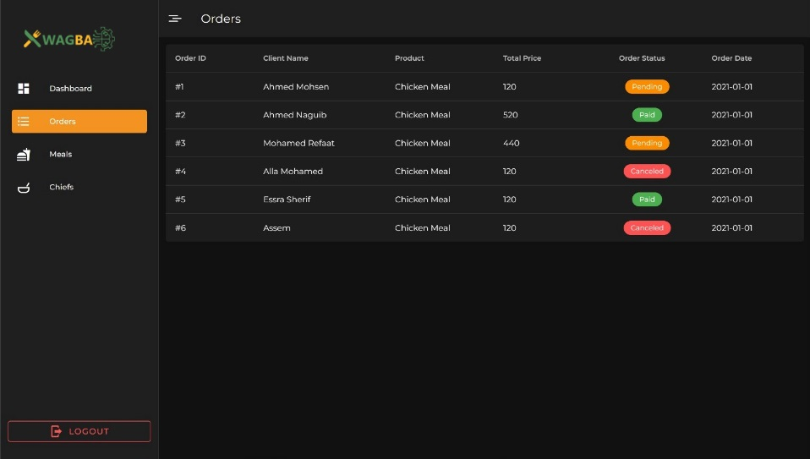

Figure 44

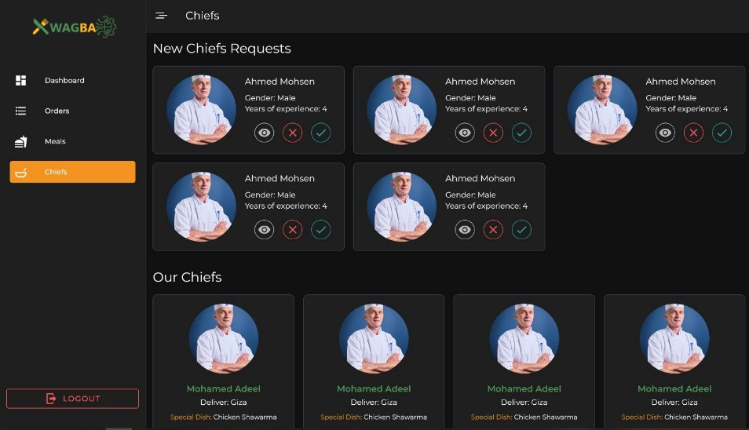

Figure 45

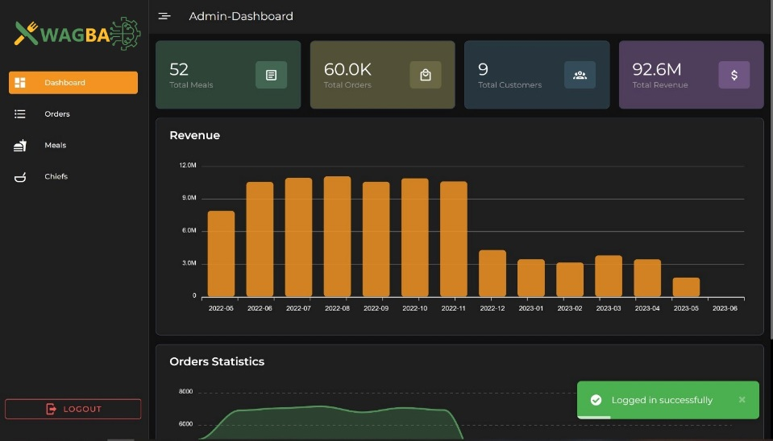

Figure 46

**Chapter ( 5 )**

**future work and Conclusion**

**Opportunities for Future Work:**

1. A company will be contracted to deliver orders in order to facilitate access to the largest possible number of customers, as well as improve service for them

1. Expand the menu: The website can expand its menu to include a wider variety of dishes. This will attract customers with different tastes and preferences, and increase the website's revenue.

1. Offer customizable options: The website can offer customizable options for customers who have dietary requirements or preferences. This will help build customer loyalty and increase customer satisfaction.

1. Introduce meal plans: The website can offer weekly or monthly meal plans for customers who want to order food in bulk or have a preplanned menu. This will provide customers with convenience and help the website to increase sales.

1. Collaborate with local farmers: The website can partner with local farmers to source fresh and organic ingredients for its recipes. This will help to build relationships with local producers and promote sustainability.

1. Introduce subscription services: The website can offer subscription services to customers who want to receive regular deliveries of food or have access to exclusive deals and discounts. This will help to build customer loyalty and increase revenue.

1. Enhance the website's user experience: The website can improve its design and functionality to make it easier for customers to navigate, find what they're looking for, and place orders. This will increase customer satisfaction and improve the website's reputation.

1. Implement customer feedback: The website can gather feedback from customers and use it to improve its offerings. This can include introducing new dishes or improving the quality of existing ones. This will help to increase customer satisfaction and loyalty.

**Conclusion**

Starting an online homemade food system can be a fantastic opportunity to share your love of food with others and turn your passion into a successful business. It allows you to be your own boss, control your schedule, and be a part of the growing demand for healthy, locally-sourced meals. By putting in the hard work and dedication required to make your business a success, you can make a positive impact on your community and potentially even inspire others to follow in your footsteps. Overall, starting an online homemade food system can be a challenging but rewarding experience that allows you to share your skills and passion with others while building a successful business

On our website, we have provided some of the requirements that concern the customer, most notably

1-Provide all categories of home food

2-Provide better services

3-Connect with available home chefs

We also used data analysis in order to limit the number of orders and work to improve quality for customers and also calculate the profit for the owner of the project and present analytical processes on how to improve the product and work to attract a larger number of customers

The website's primary strength is its ability to provide a variety of homemade meals to customers. The website offers customized meal plans to cater to customers' dietary restrictions and preferences. The website's user interface is easy to navigate, and the ordering process is simple and efficient. The website uses high-quality images and detailed descriptions of the dishes, which helps customers make informed choices and enhances their overall experience. The website has a strong social media presence and positive customer reviews, which increases its credibility and reach.

The online homemade food website has many opportunities to expand its services and customer base. The website can collaborate with local farmers and suppliers to source high-quality ingredients and promote sustainable agriculture. The website can also offer cooking classes and workshops to educate customers about healthy eating habits and cooking techniques. The website can also partner with local charities and food banks to donate meals to those in need, which can enhance the website's social responsibility and reputation

**Recommendations:** Based on the SWOT analysis, the following recommendations are provided to improve the website's performance:

1. Implement rigorous quality checks, proper packaging, and transparent communication with customers to ensure food safety and quality control.
2. Improve logistics and delivery services to ensure timely delivery and customer satisfaction.
3. Collaborate with local farmers and suppliers to source high-quality ingredients and promote sustainable agriculture.
4. Offer cooking classes and workshops to educate customers about healthy eating habits and cooking techniques.
5. Partner with local charities and food banks to donate meals to those in need, which can enhance the website's social responsibility and reputation.

information about the person recognized [1]. The detection and recognition of human

faces play an important role in areas such as video surveillance, security, and facial

image data management [2]. Facial recognition systems and similar biometric systems

(3D scanning of the face, geometric analysis of the face, etc.) present a similar

methodology. The process begins with the detection of the face, here the face area is

identiﬁed. In a second stage the intrinsic characteristics of the face are examined and

extracted; Focusing on those features that allow isolating the face of the individual

within a set of images. Finally, the veriﬁcation of the person is carried out.

information about the person recognized [1]. The detection and recognition of human

faces play an important role in areas such as video surveillance, security, and facial

image data management [2]. Facial recognition systems and similar biometric systems

(3D scanning of the face, geometric analysis of the face, etc.) present a similar

methodology. The process begins with the detection of the face, here the face area is

identiﬁed. In a second stage the intrinsic characteristics of the face are examined and

extracted; Focusing on those features that allow isolating the face of the individual

within a set of images. Finally, the veriﬁcation of the person is carried out.

Fa

cial recognition is a very active research area in the ﬁeld of computer vision, the

main basis is the correspondence of the detected face with the user’s record in the

training base. The facial recognition process implements algorithms that detect the

facial area, process the obtained image, then the extraction of facial features is per-

formed, here we obtain the fundamental information of the facial features and intrinsic

characteristics of each face (eyes, nose, chin, eyebrows, mouth, etc.), which generates a

unique bio-metric pattern for each individual.

These algorithms have different accuracy rates, in different conditions such as

lighting, distance, movement, camera quality, background, and contrast. Generally,

facial recognition uses the PCA algorithm (Principal Component Analysis), and the

Eigenfaces algorithm, the combination of these allows to recognize of an unknown test

image, compares it with the training images stored in the database and obtains

Facial recognition is a very active research area in the ﬁeld of computer vision, the

main basis is the correspondence of the detected face with the user’s record in the

training base. The facial recognition process implements algorithms that detect the

facial area, process the obtained image, then the extraction of facial features is per-

formed, here we obtain the fundamental information of the facial features and intrinsic

characteristics of each face (eyes, nose, chin, eyebrows, mouth, etc.), which generates a

unique bio-metric pattern for each individual.

These algorithms have different accuracy rates, in different conditions such as

lighting, distance, movement, camera quality, background, and contrast. Generally,

facial recognition uses the PCA algorithm (Principal Component Analysis), and the

Eigenfaces algorithm, the combination of these allows to recognize of an unknown test

image, compares it with the training images stored in the database and obtains

Facial recognition is a very active research area in the ﬁeld of computer vision, the

main basis is the correspondence of the detected face with the user’s record in the

training base. The facial recognition process implements algorithms that detect the

facial area, process the obtained image, then the extraction of facial features is per-

formed, here we obtain the fundamental information of the facial features and intrinsic

characteristics of each face (eyes, nose, chin, eyebrows, mouth, etc.), which generates a

unique bio-metric pattern for each individual.

These algorithms have different accuracy rates, in different conditions such as

lighting, distance, movement, camera quality, background, and contrast. Generally,

facial recognition uses the PCA algorithm (Principal Component Analysis), and the

Eigenfaces algorithm, the combination of these allows to recognize of an unknown test

image, compares it with the training images stored in the database and obtains

Facial recognition is a very active research area in the ﬁeld of computer vision, the

main basis is the correspondence of the detected face with the user’s record in the

training base. The facial recognition process implements algorithms that detect the

facial area, process the obtained image, then the extraction of facial features is per-

formed, here we obtain the fundamental information of the facial features and intrinsic

characteristics of each face (eyes, nose, chin, eyebrows, mouth, etc.), which generates a

unique bio-metric pattern for each individual.

These algorithms have different accuracy rates, in different conditions such as

lighting, distance, movement, camera quality, background, and contrast. Generally,

facial recognition uses the PCA algorithm (Principal Component Analysis), and the

Eigenfaces algorithm, the combination of these allows to recognize of an unknown test

image, compares it with the training images stored in the database and obtains

Facial recognition is a very active research area in the ﬁeld of computer vision, the

main basis is the correspondence of the detected face with the user’s record in the

training base. The facial recognition process implements algorithms that detect the

facial area, process the obtained image, then the extraction of facial features is per-

formed, here we obtain the fundamental information of the facial features and intrinsic

characteristics of each face (eyes, nose, chin, eyebrows, mouth, etc.), which generates a

unique bio-metric pattern for each individual.

These algorithms have different accuracy rates, in different conditions such as

lighting, distance, movement, camera quality, background, and contrast. Generally,

facial recognition uses the PCA algorithm (Principal Component Analysis), and the

Eigenfaces algorithm, the combination of these allows to recognize of an unknown test

image, compares it with the training images stored in the database and obtains